**FINAL YEAR PROJECT SYNOPSIS**

**E-ORGANIC**

• NAME : BHASKAR BAKSHI ROLL : 24400221002 DEPT.: IT

• NAME : SAYANJIT ROY ROLL : 24400122097 DEPT.: CSE

• NAME : MUNMUN SANA ROLL : 24400122096 DEPT.: CSE

• NAME : SUPRIYO BAIRAGI ROLL : 24400222002 DEPT.: IT

• NAME : PRITAM DAS ROLL : 24400121047 DEPT.: CSE

Under the guidance of Professor Sujit Raha,TECB

**TECHNO ENGINEERING COLLEGE BANIPUR**

**APPROVED BY AICTE, AFFILIATED TO MAKAUT, WB**

Banipur College Road, Habra - 743233

# **DECLARATION**

I hereby declare that the project entitled “___________________________________________” submitted for the B. Tech. (CSE) degree is my original work and the project has not formed the basis for the award of any other degree, diploma, fellowship or any other similar titles.

Signature of the Student

Place:

Date:

# **LIST OF FIGURES**

**Figure 1: LEVEL 0 DFD OF E-ORGANIC SYSTEM** 9

**Figure 2 : LEVEL 1 DFD OF E-ORGANIC SYSTEM** 9

**Figure 3 : ER-DIAGRAM OF E-ORGANIC SYSTEM** 10

**TABLE OF CONTENTS**

**DECLARATION** i

**LIST OF FIGURES** ii

**1.** **INTRODUCTION** 1

**1.1 Problem Definition** 1

**1.2 Project Overview/Specifications** 1

1.2.1 Core Objectives: 2

1.2.2 Specifications Overview: 2

**1.3 Hardware Specifications** 3

**1.4 Software Specifications** 3

**2. LITERATURE SURVEY** 5

**2.1 Existing System** 5

**2.2 Proposed System** 6

**2.3 Feasibility Study** 7

2.3.1 Technical Feasibility 7

2.3.2 Operational Feasibility 7

2.3.3 Economic Feasibility 8

**3. SYSTEM ANALYSIS & DESIGN** 9

**3.1 Data Flow Diagram** 9

**3.2 Entity Relationship Diagram** 10

**3.3 MODULE DESCRIPTION** 11

**4. FUTURE SCOPE** 13

**4.1 Technological Enhancements** 13

**4.2 Expansion of Features** 13

**4.3 Operational Scalability** 14

**4.4 Data-Driven Innovations** 14

**5. CONCLUSION** 15

**6. REFERENCE** 16

# **INTRODUCTION**

## **1.1 Problem Definition**

#### In the modern era, there is a growing demand for organic products due to their health benefits and environmental sustainability. However, buyers face challenges in finding reliable sources, and sellers struggle to reach their target audience. Traditional markets often lack transparency, variety, and quality assurance for organic fruits and vegetables. E-Organic addresses these challenges by providing a platform that bridges the gap between buyers and sellers of organic products, ensuring quality, convenience, and trust.

The organic produce industry faces numerous challenges that hinder its growth and accessibility:

1. **Unorganized Supply Chain:**
   * Many organic farmers lack the infrastructure to market their products to a wider audience.
   * Buyers often rely on intermediaries, leading to increased costs and reduced profits for sellers.
2. **Quality Assurance Issues:**
   * Lack of standardized certification processes creates mistrust among buyers regarding the authenticity of organic produce.
3. **Time and Accessibility Constraints:**
   * Traditional markets may not always be within reach for buyers seeking fresh organic products.
   * Sellers face difficulty in advertising their products without incurring high costs.
4. **Technological Gap:**
   * Many small-scale organic producers are unfamiliar with online marketplaces, making it challenging to leverage technology for sales.

## **1.2 Project Overview/Specifications**

**E-Organic** is an e-commerce platform aimed at facilitating seamless trade between buyers and sellers of organic fruits and vegetables. It also serves as a marketplace for promoting sustainability and healthy lifestyles.

### ****1.2.1 Core Objectives:****

1. **Seamless Buyer-Seller Interaction:**

Facilitate direct communication between buyers and sellers to improve transparency and trust.

1. **Enhanced Product Discoverability:**

Provide buyers with intuitive tools to search and filter products based on location, price, category, and seller reviews.

1. **Efficient Product Management for Sellers:**

Enable sellers to manage their inventory, showcase products, and analyze sales performance.

1. **Secure and Transparent Transactions:**

Implement a robust payment system with secure gateways to ensure smooth financial transactions.

1. **Data Integrity and Security:**

Protect user data through encryption, authentication, and secure hosting infrastructure.

1. **Promote Sustainable Practices:**

Support local farmers and businesses by offering a platform to sell certified organic products.

1. **Support System for User Queries:**

Provide an integrated help desk for resolving user concerns through live chat, FAQs, and ticket management.

### ****1.2.2 Specifications Overview:****

* **Target Audience:**
  + **Buyers:** Individuals or businesses looking for authentic organic produce.
  + **Sellers:** Small-scale farmers, organic product suppliers, and distributors.
* **Platform Features:**
  + Buyer-Seller interaction tools (chat, reviews).
  + Secure payment and order tracking.
  + Support system for query resolution.
* **Future Scalability:**
  + Expansion to include organic packaged goods, dairy, and other sustainable products.
  + Integration with delivery partners for logistics management.

## **1.3 Hardware Specifications**

A reliable hardware setup ensures smooth development, testing, and deployment of the E-Organic platform.

**Development Environment:**

* **Processor**: Intel Core i5/i7 or equivalent AMD Ryzen 5/7.
* **RAM**: Minimum 8GB (16GB recommended).
* **Storage**: 256GB SSD (or higher for faster build processes).
* **Graphics**: Integrated or Dedicated GPU (if required for frontend design).

**Production Environment (Server Requirements):**

* **Server Type:** Cloud-based Virtual Machine (e.g., AWS EC2, Google Cloud Compute).
* **CPU:** Multi-core processor (e.g., 8 vCPUs).
* **RAM:** 16GB for initial deployment, scalable to 32GB+ based on traffic.
* **Storage:** SSD with a minimum of 100GB for dynamic and static content storage.
* **Bandwidth:** 1 Gbps connection for handling concurrent users.

**User Devices:**

* The platform will support a wide range of user devices, including:
  + **Desktops:** Running Windows, macOS, or Linux.
  + **Mobile Devices:** Smartphones and tablets (iOS and Android).

## **1.4 Software Specifications**

**E-Organic** will be built on a modern, efficient software stack to ensure scalability, maintainability, and ease of use.

**Frontend Technologies:**

* **HTML5 & CSS3:** For webpage structure and design.
* **ReactJS:** A robust framework for building dynamic user interfaces.
* **Tailwind CSS:** For consistent and responsive design elements.

**Backend Technologies:**

* **Node.js:** For server-side scripting.
* **Express.js:** A minimal web application framework.
* **Database:** MySQL/PostgreSQL (for structured data) with optional MongoDB for unstructured data.

**Key Features:**

* **Authentication:** Implemented using JWT (JSON Web Tokens) for secure login.
* **Authorization:** Role-based access control (RBAC) to distinguish between buyers, sellers, and admin.
* **APIs:** RESTful APIs for communication between the frontend and backend.
* **Payment Gateway Integration:** Stripe, PayPal, or Razorpay for secure transactions.

**Development Tools:**

* **Code Editor:** Visual Studio Code or IntelliJ IDEA.
* **Version Control:** Git with GitHub or GitLab.
* **Testing Tools:** Jest for unit testing, Selenium for UI testing.

**Hosting:**

* **Cloud Provider:**
  + AWS (preferred for scalability).
  + Firebase or Netlify for deploying frontend assets.
* **CI/CD Tools:** Jenkins, GitHub Actions for automated testing and deployment.

**Operating Systems:**

* Development: Compatible with Windows 10/11, macOS Monterey, or Linux Ubuntu.
* Production: Linux Ubuntu Server 20.04 LTS or CentOS 8.

**Additional Software Considerations:**

1. **Security Tools:**
   1. Implement HTTPS using SSL/TLS certificates for secure communication.
   2. Regular penetration testing for vulnerabilities.
2. **Analytics Tools:**
   1. Google Analytics or Mixpanel for tracking user behavior and engagement.

# **2. LITERATURE SURVEY**

## **2.1 Existing System**

#### ****Overview of Existing Solutions****

1. **Offline Systems:**
   * Organic farmers and sellers primarily rely on physical markets and local distribution networks.
   * Buyers often visit farmers' markets or specialty stores for organic products.

**Challenges with Offline Systems:**

* Limited reach to buyers outside the local area.
* Time-consuming for buyers to explore options physically.
* Sellers struggle to attract a broader audience, reducing profitability.

1. **Online General E-Commerce Platforms (Amazon, Flipkart, etc.):**
   * These platforms include organic products in their vast inventory but lack exclusivity.

**Challenges with General Platforms:**

* Organic products are hard to distinguish from conventional items.
* Limited certification verification, leading to distrust in authenticity.
* Sellers must compete with non-organic products, often losing due to higher prices of organic goods.

1. **Dedicated Organic Platforms (Small-Scale Marketplaces):**
   * Few platforms are exclusively dedicated to organic products but remain regional or limited in features.

**Challenges with Existing Organic Platforms:**

* Poor scalability and limited reach to global markets.
* Lack of user-friendly tools for buyers and sellers.
* High platform charges, making it unaffordable for small-scale farmers.

## **2.2 Proposed System**

The **E-Organic** platform is a solution tailored to bridge the gaps identified in existing systems, offering a specialized, feature-rich marketplace exclusively for organic products.

#### ****Unique Features of the Proposed System****

1. **Organic-Only Marketplace:**
   * Exclusively features organic-certified products.
   * Verification mechanisms for seller certifications ensure buyer trust.
2. **Enhanced Buyer Features:**
   * Advanced search filters by location, price, categories, and seller ratings.
   * Wishlist functionality for saving favorite items.
   * A simplified, secure checkout process with real-time order tracking.
3. **Comprehensive Seller Tools:**
   * Product listing management, including detailed descriptions and images.
   * Real-time sales analytics to monitor performance.
   * Direct buyer communication for personalized support and transparency.
4. **Focus on Freshness and Proximity:**
   * Buyers can search for nearby sellers to ensure faster delivery and fresher produce.
5. **Transparency and Trust:**
   * Buyers can view seller profiles, organic certifications, and reviews.
   * Sellers can highlight unique farming practices or sustainability efforts.
6. **Secure Payments:**
   * Integrates reliable payment gateways like Stripe and PayPal with end-to-end encryption.
7. **Future-Proof Design:**
   * Built to scale with features like multilingual support, AI-driven product recommendations, and global logistics integration.

## **2.3 Feasibility Study**

### ****2.3.1 Technical Feasibility****

1. **Technology Selection:**
   * **Frontend:**
     + ReactJS for a dynamic, responsive UI.
     + Tailwind CSS for a sleek design framework.
   * **Backend:**
     + Node.js with Express.js for server-side logic.
     + RESTful APIs for seamless frontend-backend communication.
   * **Database:**
     + MySQL or PostgreSQL for structured data storage (users, orders, inventory).
     + MongoDB for flexible data needs (optional for scaling).
2. **Infrastructure:**
   * Cloud-based deployment on AWS, Google Cloud, or Firebase.
   * Use of Content Delivery Networks (CDNs) for fast load times globally.
3. **Security Measures:**
   * HTTPS for secure connections.
   * Role-based access control to manage buyer, seller, and admin privileges.
   * Multi-factor authentication for user accounts.
4. **Scalability and Integration:**
   * Designed to handle increasing user traffic through load balancers and auto-scaling features.
   * Modular architecture for easy integration of future features.

### ****2.3.2 Operational Feasibility****

1. **Ease of Use:**
   * Intuitive design ensures that both tech-savvy users and non-technical farmers can operate the platform effectively.
2. **Onboarding Process:**
   * Guided setup for sellers to list products and manage their profiles.
   * Buyers can quickly create accounts and start shopping without complications.
3. **Stakeholder Benefits:**
   * **Buyers:** Gain access to authentic organic products with transparency and support.
   * **Sellers:** Have a dedicated space to showcase and sell their products without the competition of non-organic alternatives.
   * **Admin:** Can easily manage platform operations, user disputes, and ensure compliance with platform policies.
4. **Support System:**
   * Integrated live chat, FAQs, and ticket resolution mechanisms for resolving user issues efficiently.

### ****2.3.3 Economic Feasibility****

1. **Cost Analysis:**
   * Development costs are minimized by leveraging open-source technologies.
   * Operational costs are managed through cloud infrastructure with pay-as-you-go models.
2. **Revenue Model:**
   * **Subscription Fees:** Basic and premium plans for sellers based on feature access.
   * **Transaction Charges:** A small commission on every successful transaction.
   * **Sponsored Listings:** Sellers can pay for increased visibility on the platform.
   * **Advertisements:** Targeted ads for related products and services.
3. **Return on Investment (ROI):**
   * The growing demand for organic products ensures increasing platform adoption, driving revenue growth.
4. **Profitability Timeline:**
   * Break-even is expected within 1-2 years, depending on user adoption rates and marketing effectiveness.

# **3.** **SYSTEM ANALYSIS & DESIGN**

## **3.1 Data Flow Diagram**

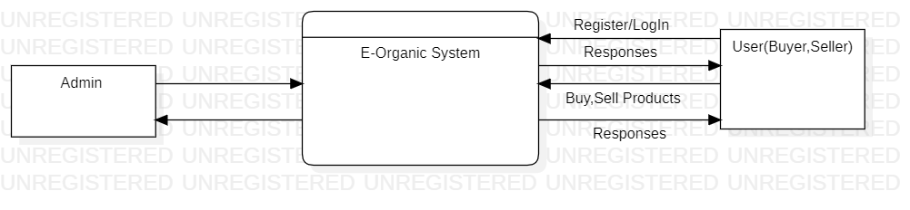

**Figure 1: LEVEL 0 DFD OF E-ORGANIC SYSTEM**

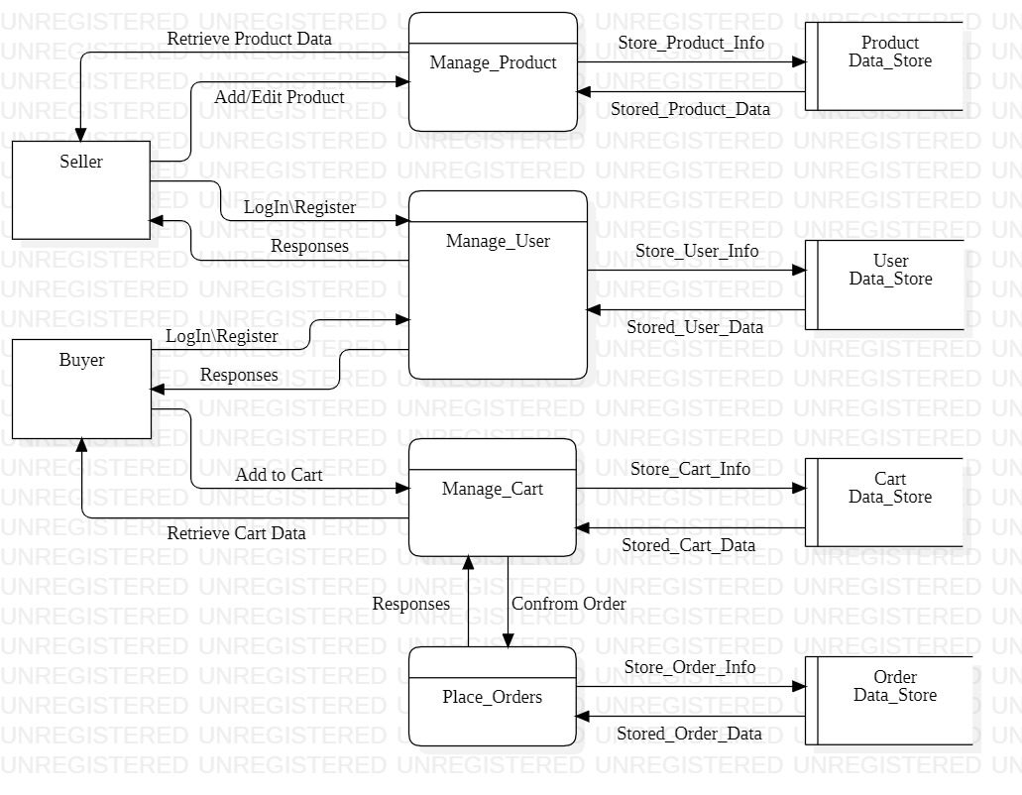

**Figure 2 : LEVEL 1 DFD OF E-ORGANIC SYSTEM**

## **3.2 Entity Relationship Diagram**

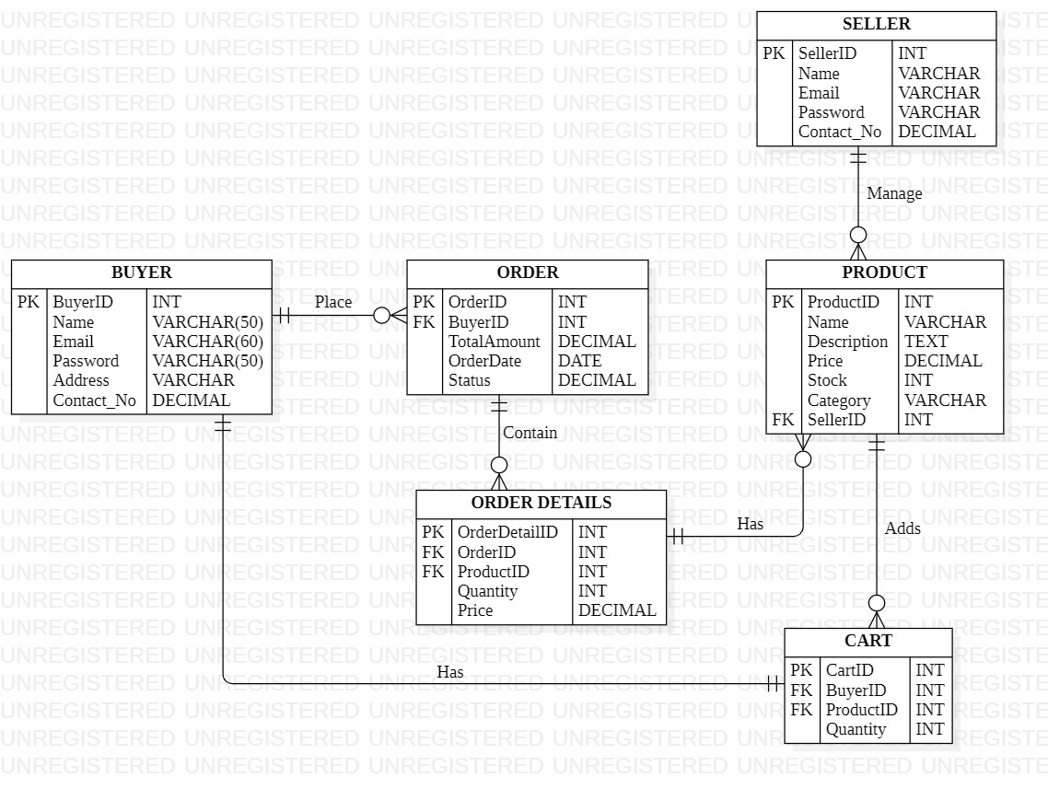

**Figure 3 : ER-DIAGRAM OF E-ORGANIC SYSTEM**

## **3.3 MODULE DESCRIPTION**

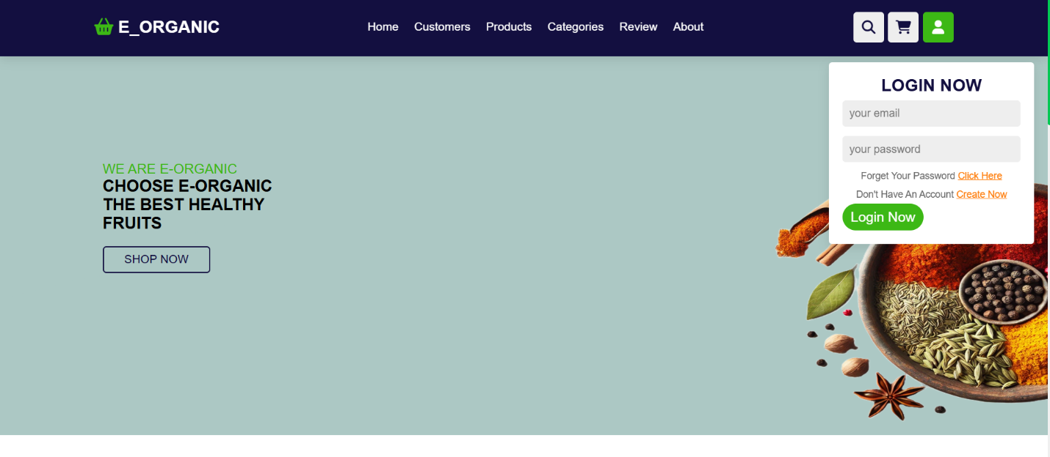

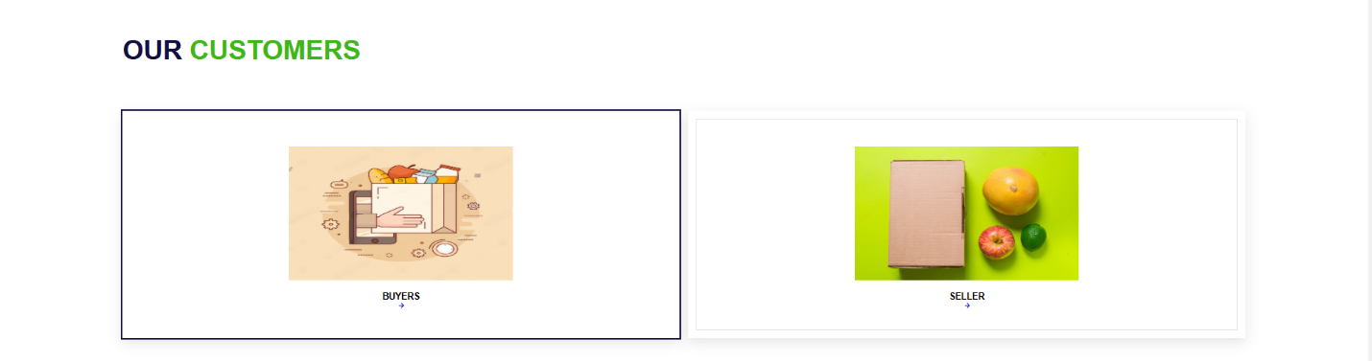

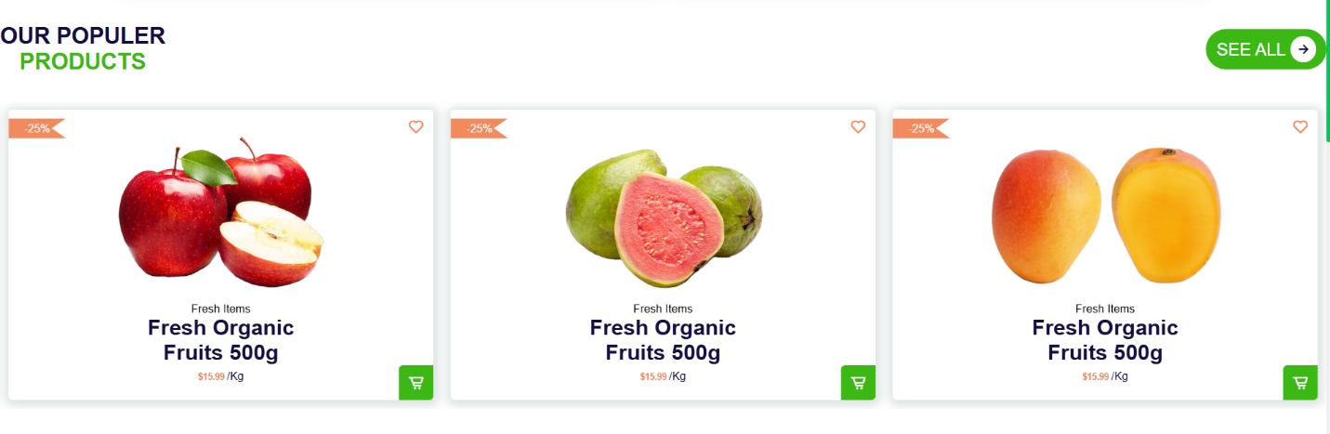

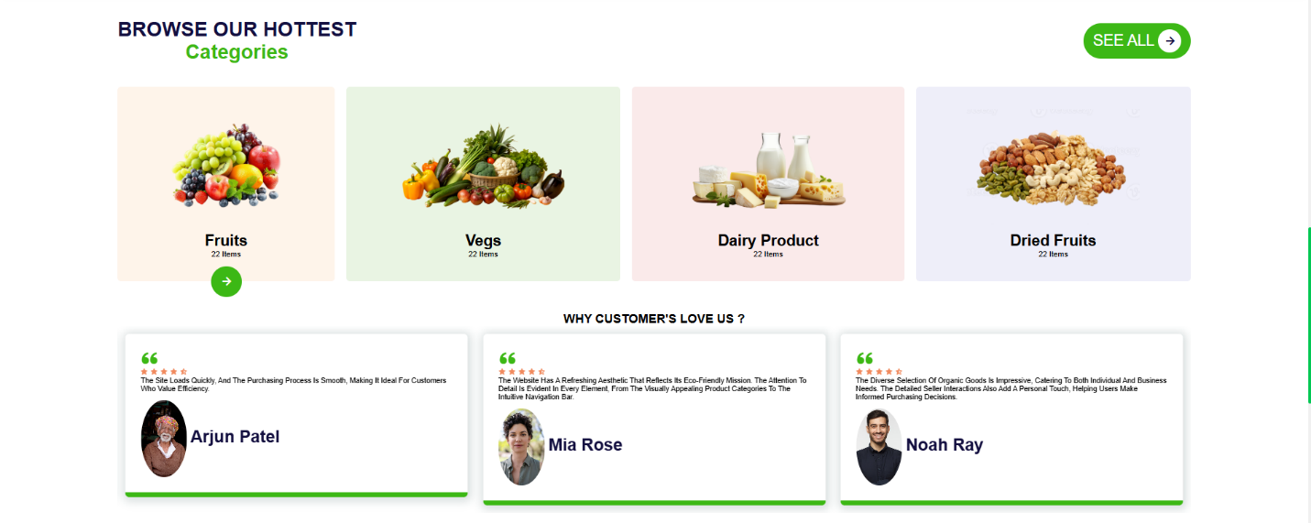

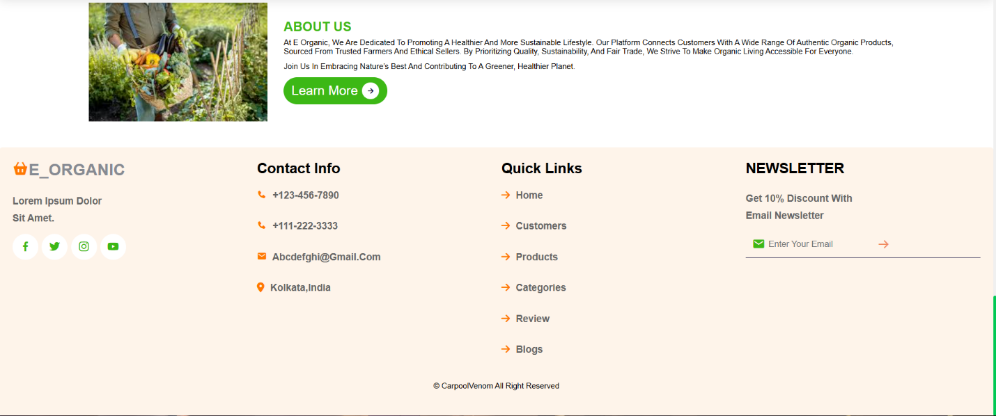

# **4. FUTURE SCOPE**

## **4.1 Technological Enhancements**

1. **Integration of Artificial Intelligence (AI):**
   * AI-driven product recommendations based on user preferences and past purchases.
   * Predictive analytics for sellers to optimize inventory and pricing strategies.
2. **Mobile Application Development:**
   * Dedicated Android and iOS apps for on-the-go access to the platform.
   * Features like push notifications for offers, order updates, and product launches.
3. **Blockchain for Transparency:**
   * Use blockchain technology to verify and track the authenticity of organic certifications and the supply chain.
   * Provide tamper-proof records of product origin, farming practices, and certifications.
4. **Voice and Chat Assistants:**
   * Integration of virtual assistants like Alexa or Google Assistant for voice-based shopping.
   * AI-powered chatbots for instant customer support and product inquiries.

## **4.2 Expansion of Features**

1. **International Market Support:**
   * Enable cross-border trade of organic products with currency conversion and international shipping integration.
   * Support for multiple languages to cater to global users.
2. **Subscription-Based Delivery Services:**
   * Introduce subscription options for regular delivery of products like vegetables, fruits, or dairy.
   * Personalized subscription plans based on buyer preferences.
3. **Farm-to-Table Services:**
   * Facilitate direct connections between farmers and end consumers, bypassing intermediaries.
   * Add features for buyers to book visits to farms for authenticity verification.
4. **Community and Learning Modules:**
   * Include forums or blogs where sellers can share farming techniques, and buyers can learn about the benefits of organic living.
   * Conduct virtual workshops or webinars for users interested in organic farming or healthy lifestyles.

## **4.3 Operational Scalability**

1. **Enhanced Logistics Support:**
   * Partner with third-party logistics providers to ensure efficient delivery, especially for perishable goods.
   * Introduce real-time order tracking for buyers.
2. **Warehouse and Cold Storage Solutions:**
   * Collaborate with storage providers to offer sellers cold storage options for perishable goods.
   * Centralized warehouses for faster last-mile deliveries.
3. **Sustainability Initiatives:**
   * Encourage eco-friendly packaging options for sellers.
   * Reward buyers and sellers who participate in sustainability programs, such as reduced carbon footprint deliveries.

## **4.4 Data-Driven Innovations**

1. **Data Analytics for Sellers:**
   * Provide sellers with insights into sales trends, customer preferences, and demand forecasting.
2. **Market Expansion Strategies:**
   * Use collected data to identify underserved markets and plan strategic expansions.
3. **Personalized Marketing:**
   * Employ user behavior data for targeted marketing campaigns, including email marketing and personalized offers.

# **5. CONCLUSION**

The development of the **E-Organic** platform marks a significant step toward transforming the organic marketplace. With the growing global demand for organic products, the platform serves as a bridge connecting buyers seeking authenticity and sellers striving to reach a broader audience. Through features like product authenticity verification, a user-friendly interface, and advanced logistics, the platform ensures a seamless shopping experience while maintaining transparency and trust.

Moreover, **E-Organic** not only supports the organic farming community but also contributes to larger societal goals such as environmental sustainability, healthier lifestyles, and local economic growth. By offering tools and resources to small-scale farmers and producers, the platform empowers them to compete in the digital era, ensuring fair opportunities for all stakeholders.

The scalability and future-oriented design of the platform ensure its adaptability to evolving market trends and technological advancements. With planned expansions into AI-driven recommendations, blockchain transparency, and international logistics, **E-Organic** is set to become a leader in the organic e-commerce domain.

Ultimately, the success of **E-Organic** lies in its commitment to quality, innovation, and community engagement. It not only solves existing challenges but also lays the groundwork for a sustainable and thriving organic ecosystem. This initiative reflects the potential of technology in driving positive change and fostering a healthier, more connected world.

# **6. REFERENCE**

1. **Books and Journals:**
   * "E-Commerce and Organic Marketplaces" – John Wiley & Sons, 2022.
   * "Advances in Organic Certification and Market Transparency" – Elsevier Journal, 2021.
2. **Websites and Online Resources:**
   * "The Organic Trade Association: Market Insights and Trends" – [www.ota.com](https://www.ota.com/).
   * "World Organic Market Statistics 2023" – [www.organic-market.info](https://www.organic-market.info/).
   * "E-Commerce Frameworks for Specialized Markets" – [developer.mozilla.org](https://developer.mozilla.org/).
3. **Reports and Case Studies:**
   * "The Rise of Organic E-Commerce: Opportunities and Challenges," McKinsey & Company, 2023.
   * "Blockchain in Organic Supply Chains," World Economic Forum White Paper, 2022.